**Title page**

| **Name** | **Student ID** |
| --- | --- |
| Yasin Celik | 99112486 |
| Gianni Pessotto | 13199219 |
| Daniel Boustani | 13207509 |

**Abstract** **3**

**Introduction** **3**

Background 3

Use-cases 3

**System modelling** **4**

Data model 4

User profiles 4

Workflow diagrams 4

Prototype system screens 4

**Conclusion** **5**

**References** **6**

# Abstract

Abstract (about 100 words)

The rise in cloud computing despite its issues, has benefits that far outweigh these issues. It is an eventuality that cloud computing will be the future of technology and so to adopt it now or in the near future would have significant benefits, such as the ability to easily upgrade to newer cloud applications and acquire early adopter bonuses. Applying cloud computing to the order management in this scenario will illustrate how and why such an adoption to cloud computing not only provides bonuses in the future, but also the benefits of adopting it today especially for a large business.

# Introduction

## Background

A brief background of the organization that is requesting Force.com PaaS implementation

The organisation requesting this Force.com PaaS implementation, is that of Order Management. Order Management is one of the most crucial areas in any business as the business cannot proceed or progress without the ability to manage orders, whether it be from customers or from suppliers. By requesting and fulfilling a Paas Force.com application, Order Management can seamlessly and autonomously ensure the correct products are allocated to the correct areas in both receiving and delivering, ensuring their role is fulfilled to the letter.

## 

## Use-cases

What are the specific use-cases for using the Force.com PaaS in the above organization

Use case 1: Ordering

Story- As a Client, I want to order products for my business.

Goal- Order stock to sell

Main Flow-

1. Client logs in to the new system.
2. Client searches/selects products to order
3. Client specifies how much stock is necessary
4. The OMS system allocates from base stock produced
5. The system adds to current store stock what has been requested

Exceptions- System crashes or fails to start due to incorrect implantation (Buggy application)

Use Case 2: System Check

Story- As the CIO/CEO/Tech support, I want to see the system run successfully

Goal- Ensure proper system functionality

Main Flow-

1. CIO/CEO/Tech support logs in to the system
2. Selects screen showing records
3. Observes records, compares with written records

Exceptions- System crashes or fails to start due to incorrect implantation (Buggy application)

Use Case 3: Stock Check

Story- As part of the Order Management team, I want to ensure stock count is correct

Goal- Ensure stock count is correct

Main Flow-

1. Team member logs in to the system
2. Selects screen to observe what stock has reached the store, what stock is on the way and what is currently at that store
3. Compares to written or manual stock count

Exceptions- System crashes or fails to start due to incorrect implantation (Buggy application)

# System modelling

## Data model

Present the Data Model for the PaaS Application

The model for the data used within the PaaS system has been simplified to a client-order-product application to minimise issues and ensure easy scalability and security.

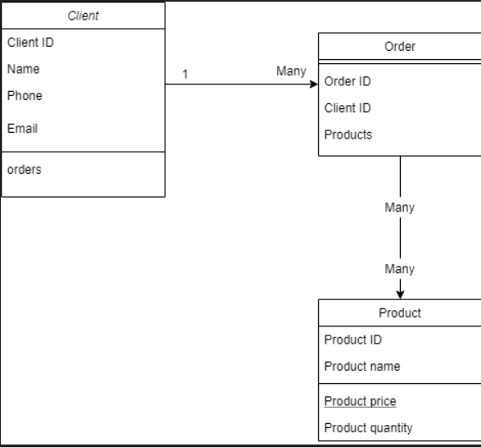

## User profiles

Present the Custom User Profile/s with descriptions of each profile

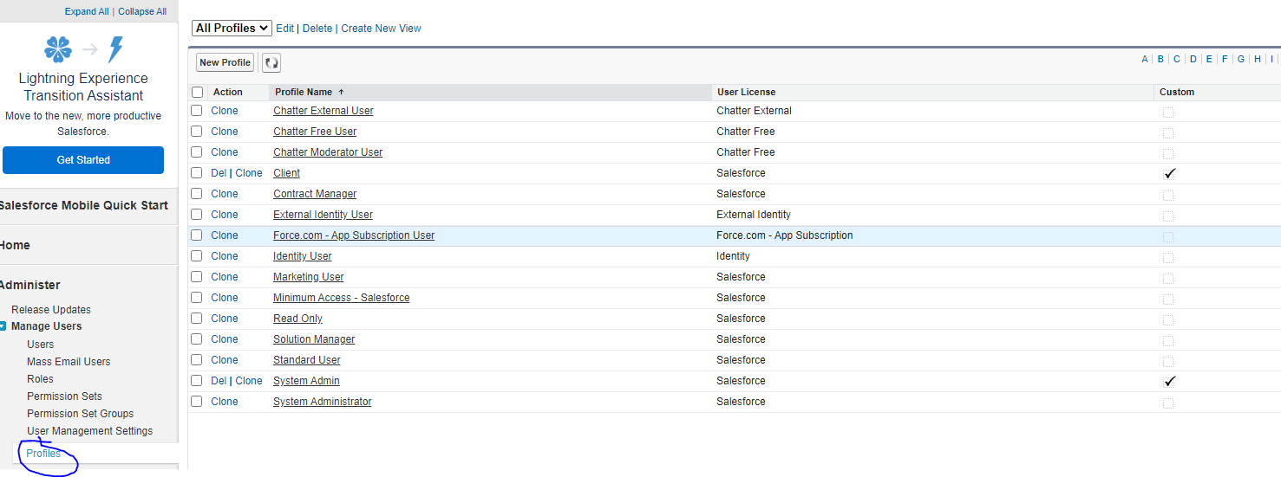

Due to the nature of the system, there are a limited number of profiles that will require access to the system or certain settings. ‘Client’ is a generalised term for the organisation receiving the PaaS software. ‘System Admin’ is the person responsible for ensuring correct system functions and can also perform employee roles in the system if they are unable to do so themselves.

Client- The client being the owner of a version of the software ensures they have limited access to customising and viewing within the software. The client being the organisation means that team members from that organisation, whether they are the CIO/CEO or employees such as a store manager, ensures that they do not have full access to certain settings, for example, object settings.

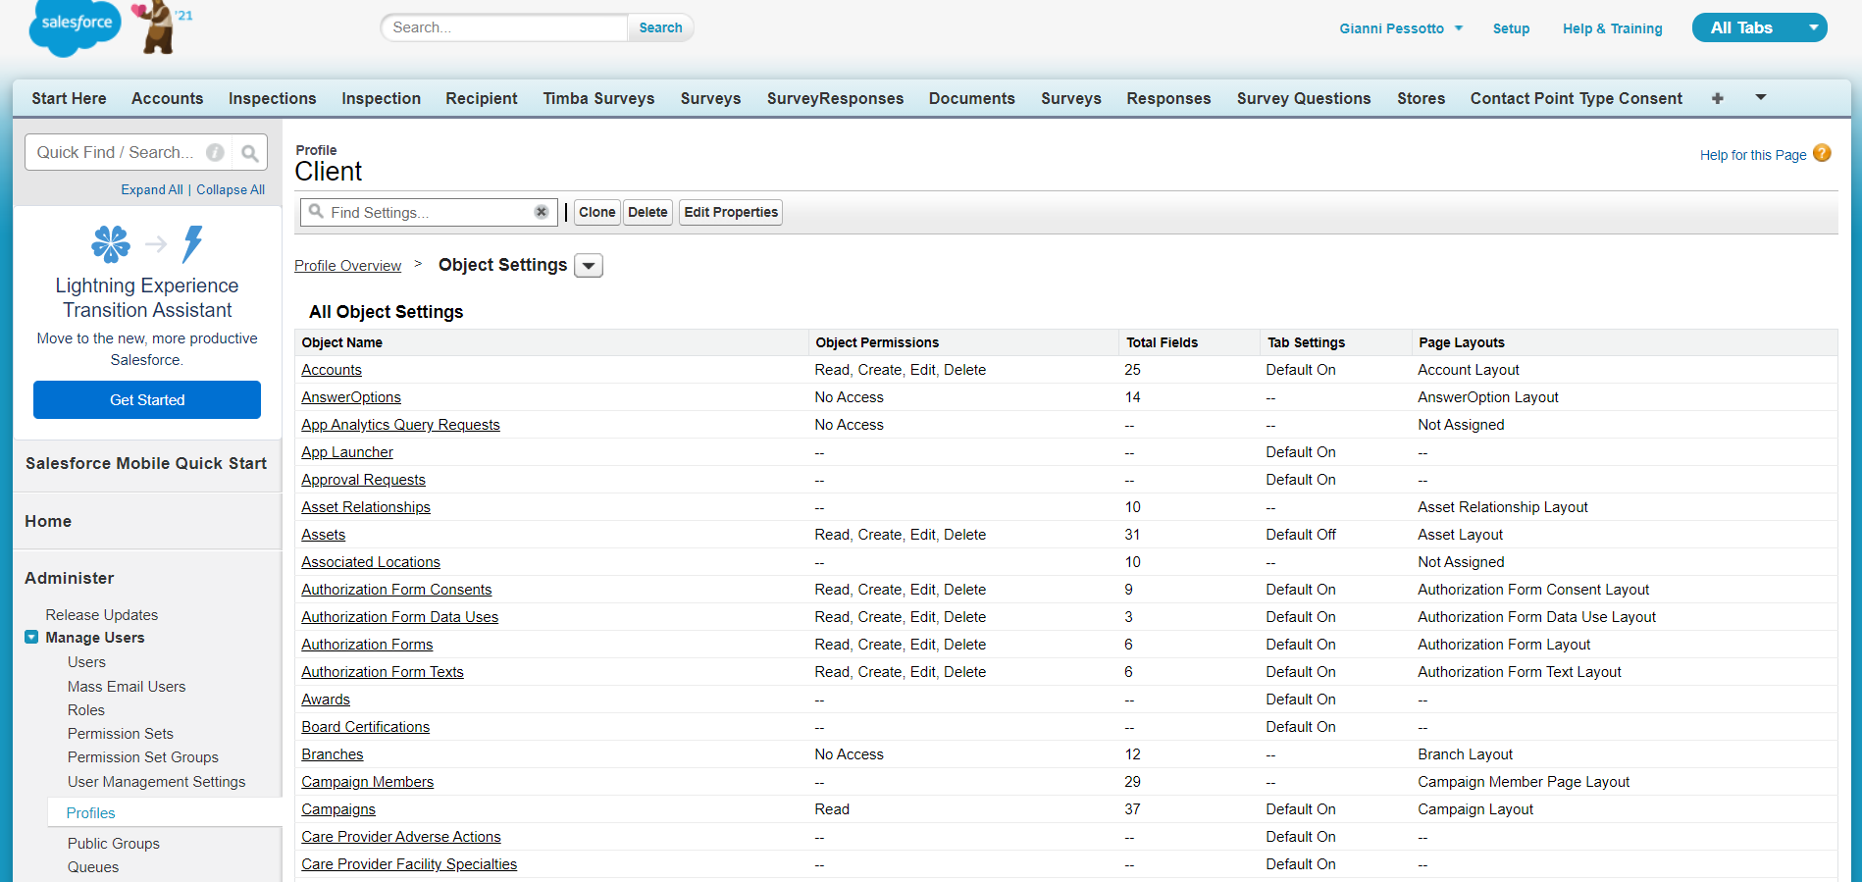

System Admin- The System administrator is the main support for ensuring the smooth and correct implementation of the PaaS order management software. The system administrator is the equivalent of the IT support for the client’s software version, thus they have full access to all features in the software. An example is that the System Admin has all permissions unlocked regarding object editing as seen in the below screenshot.

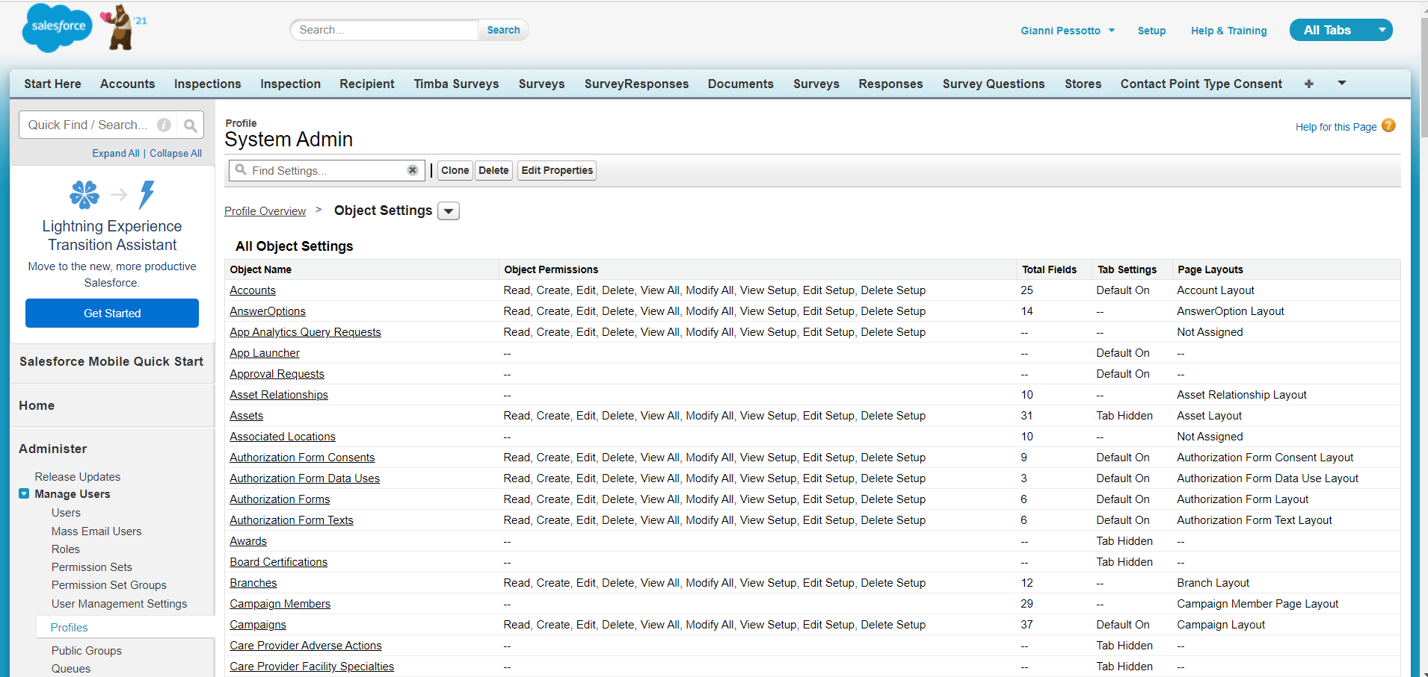

## Workflow diagrams

Present the Workflow diagrams

The first diagram is a simple one showing how employees order products using the PaaS software.

The second diagram is the process of how orders are edited or changes are made by someone in the organisation.

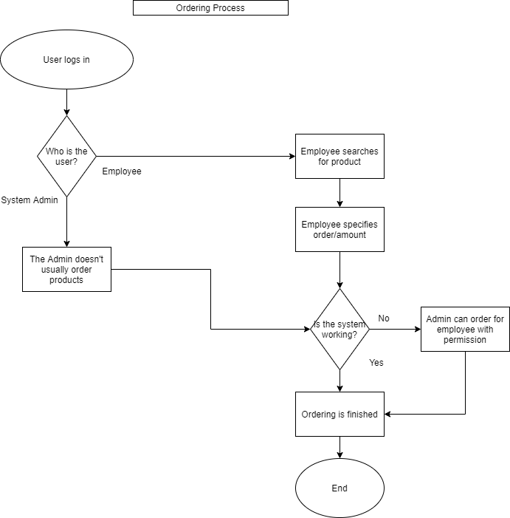

## 

## 

## 

## 

## 

## 

## 

## Prototype system screens

Prototype System Screens and Description

**Administrator view- Products**

The admin can examine all current and out of stock products. They can also modify products depending on the organisation's needs. As an admin, you can also add new products by just hitting the new products button. Which will open a new window which will look like figure 2.

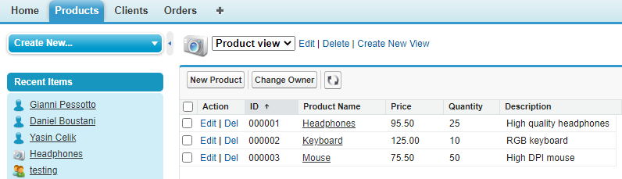

*(fig. 1)*

**Administrator - Creating a new product**

Through this screen we can create new products with a finite quantity so the client can purchase through their console.

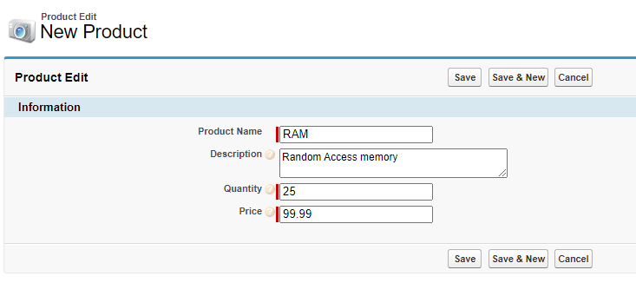

*(fig. 2)*

**Administrator view - Viewing Clients**

As you can see the admin can see all users and their details to Add, Update and delete when necessary. The client can only see his own profile.

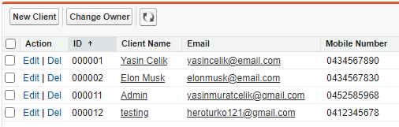

**Administrator view - Client details and orders**

Admins can check clients current orders by clicking any client. They can also edit and delete the order

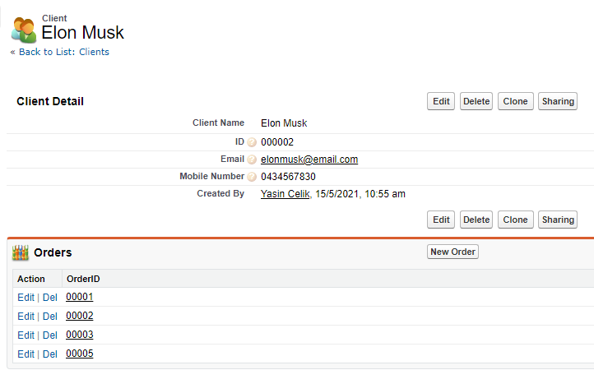

**Administrator view - Adding new client**

The admin can add many clients. A client can also create an account so can order. They cannot access other clients.

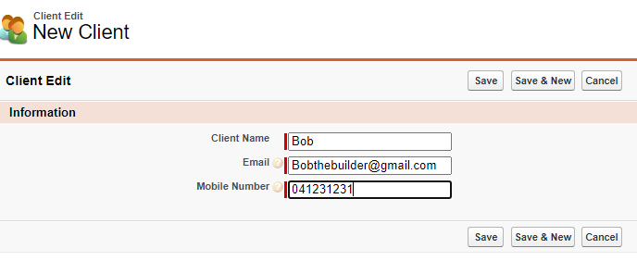

**Administrator view - Creating new order**

As an admin we can create orders for clients. We can create any order for any client. As a client we can create orders for only ourselves.

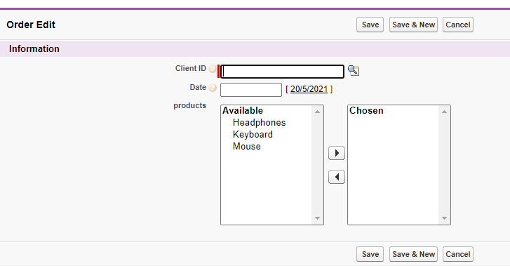

**Client views - products**

The client can only view products. They are limited from editing.

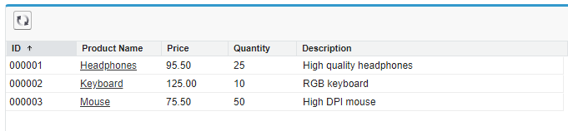

**Client view - client details**

Clients can see their own accounts and create new accounts. They can also edit their own accounts.



**Client view - client orders**

Clients can only see their own orders. And can create many orders

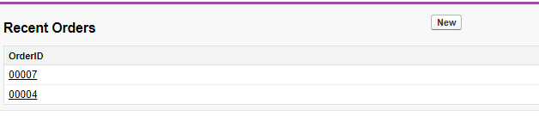

# **Group member participation**

| Name | Participation |
| --- | --- |
| Gianni Pessotto | 100% |
| Yasin Celik | 100% |
| Daniel Boustani | 100% |

# Conclusion

Conclude the report with your experience(s) with PaaS-based software development

Future further implementation of this PaaS application, and other areas within the organization where PaaS implementations could be done (along with rationale)

Platform as a Software has been excellent to work with. As a platform, the software allows for numerous options of customizability and hosting, especially as a platform for cloud based applications. The PaaS method of hosting cloud applications is quite flexible and allows for additions to be made as its a platform. However, it requires experience to effectively know and change settings to meet the requirements that are wanted. Thus, the process can be extremely complicated.

In this case, the PaaS software has great suitability. Order management is itself a platform and would be viable to extend this PaaS software to other areas of the organisation. Contract management is a similar scenario in terms of process and abilities, thus extending this application to that area would be straightforward. An additional benefit is that implementing it after Order management would incur reduced costs due to the reusability of the process as well as the assets/setting used that created the order management PaaS. Contract management is a similar scenario as it requires three sections of data alike to Order management. It has the organisation, the contract details itself and who the contract is offered to or received from.

Once Contract management has been established, it is once again, a very similar process as HR management has contract information inside it with the organisation's employees. Therefore, the application would be the same. The rest of the application concerning HR management would reside with personal details and the updating of them every so often, thus it would not be difficult to add this in after Order and Contract management.